**Topics: Normal distribution, Functions of Random Variables**

1. The time required for servicing transmissions is normally distributed with *μ* = 45 minutes and *σ* = 8 minutes. The service manager plans to have work begin on the transmission of a customer’s car 10 minutes after the car is dropped off and the customer is told that the car will be ready within 1 hour from drop-off. What is the probability that the service manager cannot meet his commitment?
2. 0.3875
3. 0.2676
4. 0.5
5. 0.6987

ANS: It is B 0.2676

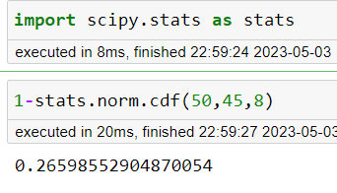

1. The current age (in years) of 400 clerical employees at an insurance claims processing center is normally distributed with mean *μ* = 38 and Standard deviation *σ* =6. For each statement below, please specify True/False. If false, briefly explain why.
2. More employees at the processing center are older than 44 than between 38 and 44.

ANS: We can find that the proportion of employees whose age is between 38 and 44 is approximately 0.3413

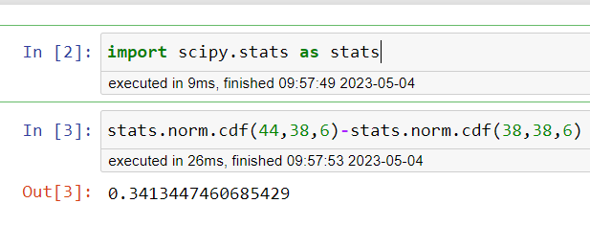

1. A training program for employees under the age of 30 at the center would be expected to attract about 36 employees.

ANS: We can find that the proportion of employees whose age is less than 30 is approximately 0.09121

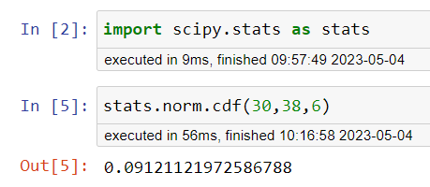

1. If *X1* ~ *N*(μ, σ2) and *X*2 ~ *N*(μ, σ2) are *iid* normal random variables, then what is the difference between 2 *X*1 and *X*1 + *X*2? Discuss both their distributions and parameters.

ANS: Let's first find the distribution and parameters for 2X1:

If X1 ~ N(μ, σ2), then 2X1 ~ N(2μ, 4σ2), since the mean and variance of a constant times a normal random variable are equal to the constant times the mean and variance of the original variable, respectively. Therefore, the distribution of 2X1 is also normal with mean 2μ and variance 4σ2.

Now let's find the distribution and parameters for X1 + X2:

Since X1 and X2 are independent normal random variables with the same mean μ and variance σ2, their sum X1 + X2 is also a normal random variable with mean μ + μ = 2μ and variance σ2 + σ2 = 2σ2. Therefore, the distribution of X1 + X2 is also normal with mean 2μ and variance 2σ2.

To summarize, the difference between 2X1 and X1 + X2 is that the former has a variance of 4σ2 while the latter has a variance of 2σ2. This means that 2X1 is more spread out than X1 + X2, and therefore has a larger standard deviation. However, both random variables have the same mean of 2μ.

In terms of their distributions, 2X1 is a scaled and shifted version of X1, while X1 + X2 is a sum of two independent normal random variables with the same mean and variance.

1. Let X ~ N(100, 202). Find two values, *a* and *b*, symmetric about the mean, such that the probability of the random variable taking a value between them is 0.99.
2. 90.5, 105.9
3. 80.2, 119.8
4. 22, 78
5. 48.5, 151.5
6. 90.1, 109.9

ANS: The answer is D 48.5, 151.5

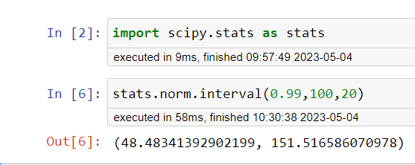

1. Consider a company that has two different divisions. The annual profits from the two divisions are independent and have distributions Profit1 ~ N(5, 32) and Profit2 ~ N(7, 42) respectively. Both the profits are in $ Million. Answer the following questions about the total profit of the company in Rupees. Assume that $1 = Rs. 45
2. Specify a Rupee range (centered on the mean) such that it contains 95% probability for the annual profit of the company.

ANS: stats.norm.interval(0.95,12*45,5*45)

(99.00810347848784, 980.9918965215122)

1. Specify the 5th percentile of profit (in Rupees) for the company

ANS: X=540+(-1.645)*(225)

np.round(X)

170.0

1. Which of the two divisions has a larger probability of making a loss in a given year?

ANS: stats.norm.cdf(0,5,3)

0.0477903522728147

stats.norm.cdf(0,7,4)

0.040059156863817086